LAB two report

This report include two sections:

1. ZigBee network layer basics.
2. Try ZigBee networking through PuTTy.

Section 1

The ZigBee coordinator use NWK (Network layer) to start new network, it can also provide new addressing to the device that joined the network.

There are three topologies for the ZigBee NWK: star, tree and mesh. For the star topology, the coordinator control other end devices directly. In Figure.1 the blue one represents the coordinator, in the PuTTy window we select option 1 and then choose enable join to let other devices join the coordinator, the pink one is an end device who join the network.

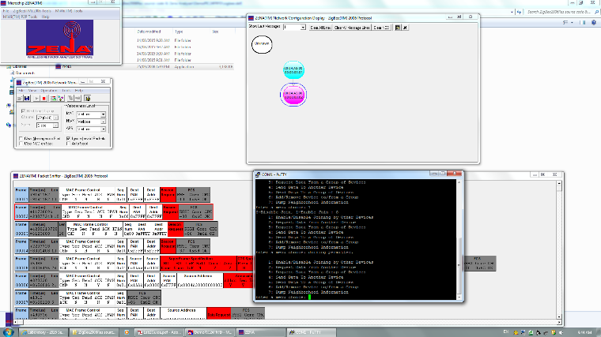

Figure.1

After that, we disable the join option of the coordinator, then setup a new device. As shown in Figure.2, the yellow one is the new device, it connects with the device we use in the last step. Otherwise, it will connect the coordinator if we do not disable the join for the coordinator, which shown in Figure.3

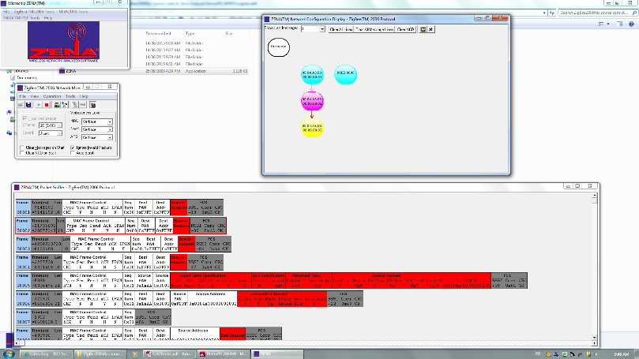

Figure.2

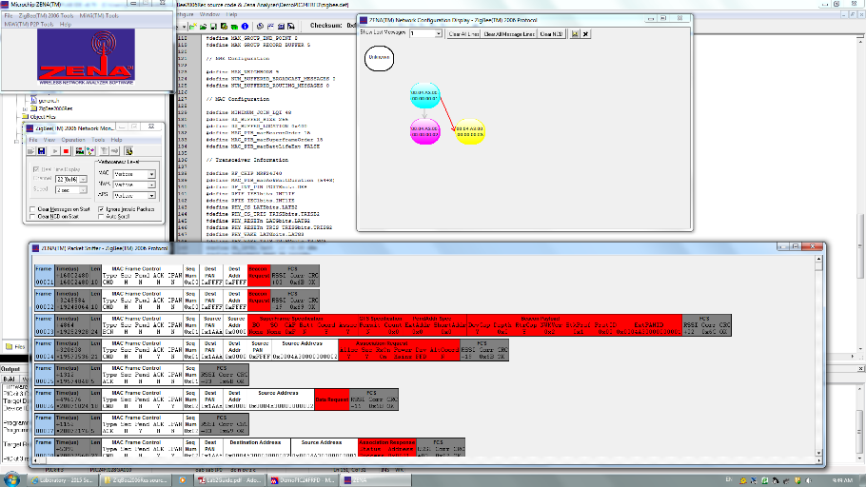

Figure.3

Here the figure.2 refers to tree topology and the Figure.3 refers to star topology.

Section 2

In this section, we establish a real ZigBee connection which include sending and receiving messages

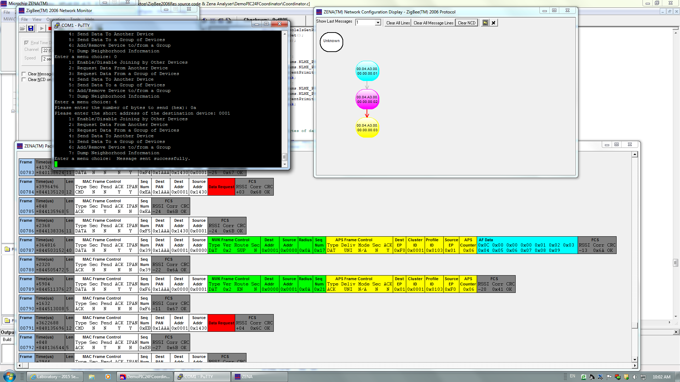

Figure.4

As shown in Figure.4, we can see MAC header (white part) and Network header (green part), in these two parts, we can easily find the Dest address and Source address.

There are three routing modes: suppress, enable and force. In this section, we only focus on the enable and suppress modes. Firstly we program the enable modes, as shown in figure.5 we write the codes from lab guide to change it.

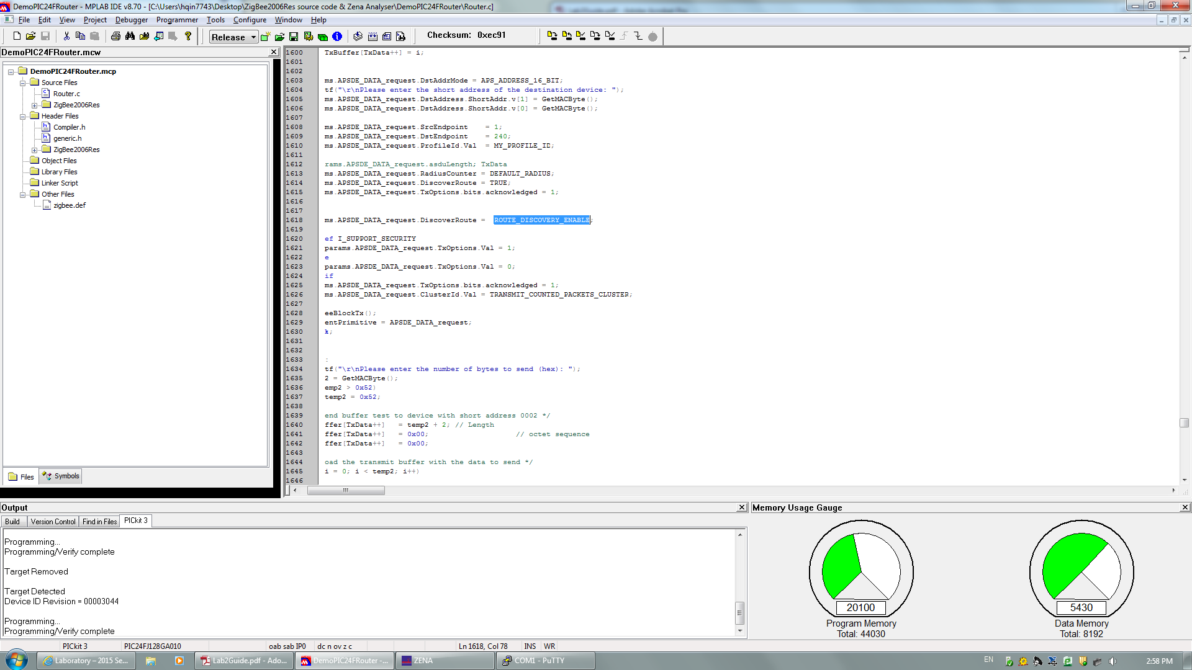

Figure.5

And now we can get the enable modes, we can check the result in Zena windows, in the Network header, we can see the EN which means the enable modes.

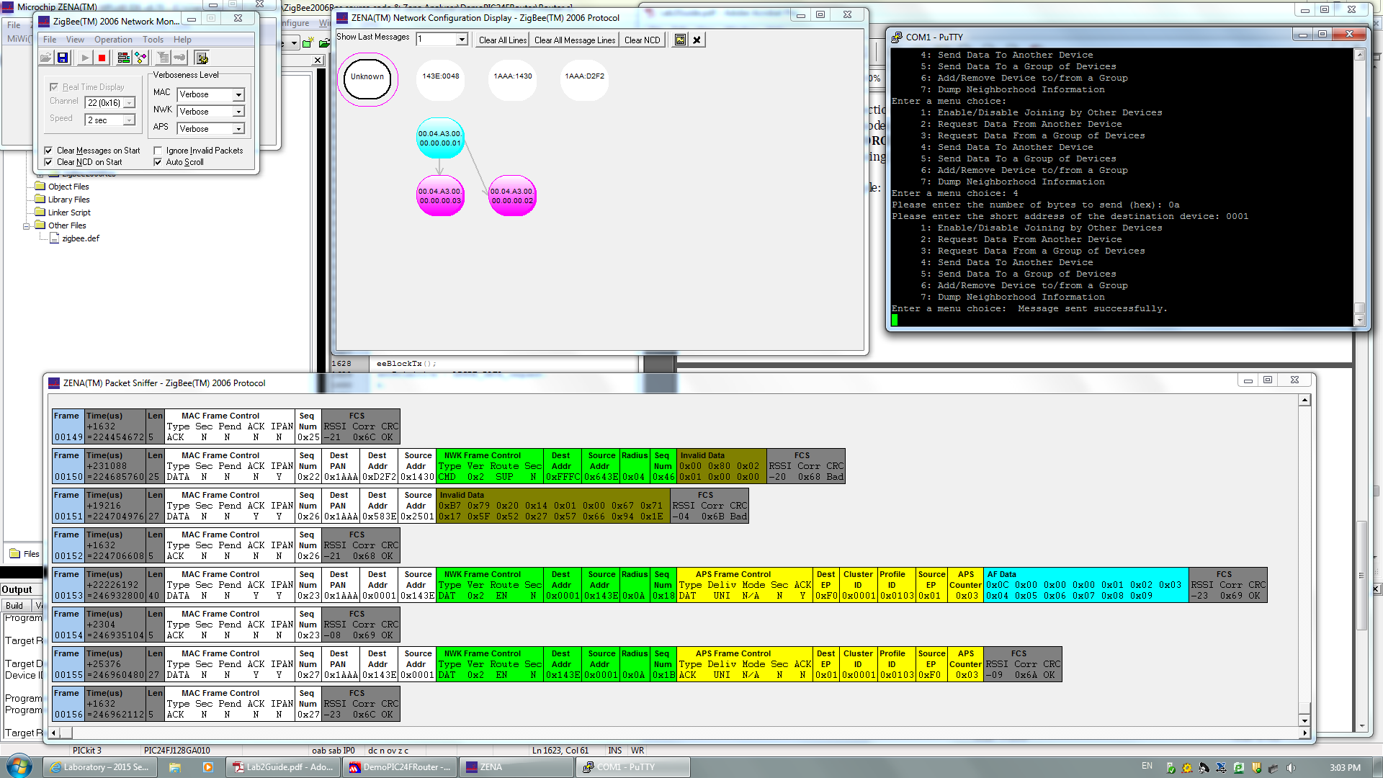

Figure.6

Next, we program the suppress modes by using the same way, as shown in figure.7.

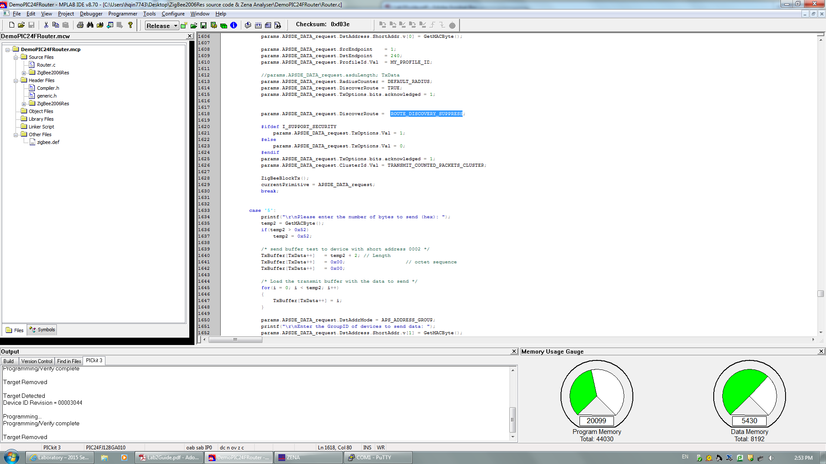

Figure.7

And now we can get a suppress modes, just check the Zena result shown in figure.8.

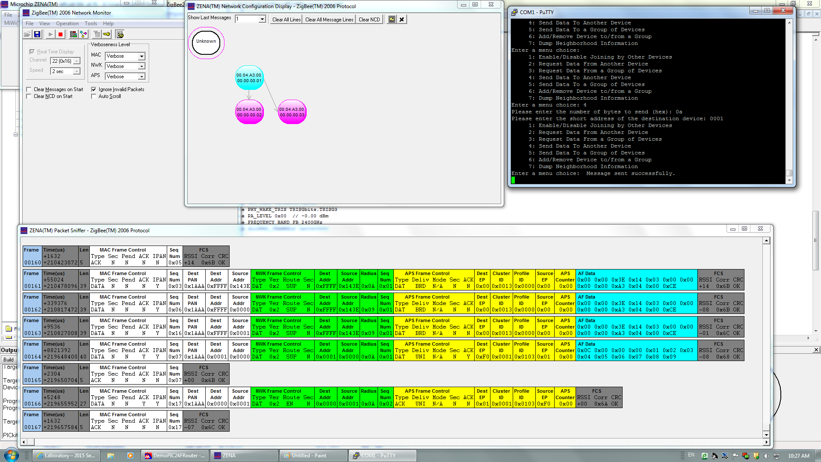

Figure.9

And now we get the suppress mode and we can see the packet capturing clearly.